Lab 5:

- Write a PHP script that generates a multiplication table.
Code:
<!DOCTYPE html>
<html>
<head>
<title>Multiplication Table</title>
<style>
table {
border-collapse: collapse;
margin: 20px;
}
td, th {
border: 1px solid black;
padding: 8px 12px;
text-align: center;
}
th {
background-color: #f2f2f2;
}
</style>
</head>
<body>

<h2>Multiplication Table (1 to 10)</h2>
<table>
<tr>
<th>*</th>
<?php
for ($i = 1; $i <= 10; $i++) {
echo "<th>$i</th>";
}
?>
</tr>
<?php
for ($i = 1; $i <= 10; $i++) {
echo "<tr>";
echo "<th>$i</th>";
for ($j = 1; $j <= 10; $j++) {
echo "<td>" . ($i * $j) . "</td>";
}
echo "</tr>";
}
?>
</table>
</body>
</html>
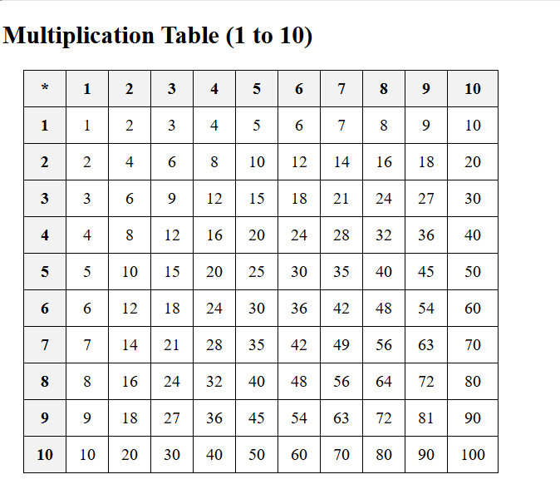

- Assign an array of numbers to a variable. Find the square of the numbers by using foreach loop.

Code:

<?php

$numbers = [2, 4, 6, 8, 10];

echo "Squares of the numbers:<br>";
foreach ($numbers as $num) {
$square = $num * $num;

echo "The square of $num is $square<br>";
}
?>

Output:

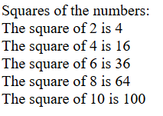

- Verify if PHP supports function overloading. Create a function that generates the sum of two numbers. Use the same function to generate the sum of 3 numbers. Illustrate the use of func_get_args for the given scenario.
Code:
<?php
function add() {

$args = func_get_args();

$sum = 0;

foreach ($args as $num) {
$sum += $num;
}

return $sum;
}

echo "Sum of 5 and 10 is: " . add(5, 10) . "<br>";

echo "Sum of 3, 7 and 2 is: " . add(3, 7, 2) . "<br>";
?>
Output:

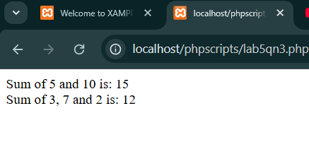

- Perform the following file operations:
a. Create a file named file.txt.
b. Write your name and roll number in the file
c. Open the file to read its contents.
d. Add current date to its contents
e. Close the file
f. Rename the file as test.txt

Code:
<?php
// STEP A
$file = fopen("file.txt", "w");
echo "a. File named file.txt has been created.<br>";

// STEP B
fwrite($file, "Name: Priyanshu\n");
fwrite($file, "Roll No: 79011070\n");
fclose($file);
echo "b. Name and roll number have been written into file.txt.<br>";

// STEP C
$file = fopen("file.txt", "r");
$contents = fread($file, filesize("file.txt"));
echo "c. Contents of file.txt:<br><pre>$contents</pre>";
fclose($file);

// STEP D
$file = fopen("file.txt", "a");
$currentDate = date("Y-m-d");
fwrite($file, "Date: $currentDate\n");
fclose($file);
echo "d. Current date has been added to file.txt.<br>";

// STEP E
echo "e. File has been closed after reading/writing.<br>";

// STEP F
rename("file.txt", "test.txt");
echo "f. File has been renamed from file.txt to test.txt.<br>";
?>

Output:
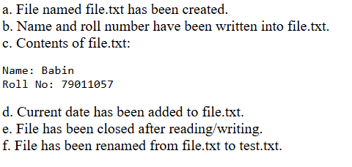

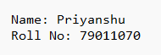

- Create a PHP script to upload an image to a directory on your server.
Code:
Html
<!DOCTYPE html>
<html>
<head>
<title>Upload Image</title>
</head>
<body>

<h2>Upload an Image</h2>

<form action="5_upload.php" method="POST" enctype="multipart/form-data">
<label>Select image:</label>
<input type="file" name="image"><br><br>
<input type="submit" name="upload" value="Upload">
</form>

</body>
</html>

Php
<?php
if (isset($_POST['upload'])) {
$targetDir = "uploads/";
$fileName = basename($_FILES["image"]["name"]);
$targetFile = $targetDir . $fileName;

$check = getimagesize($_FILES["image"]["tmp_name"]);
if ($check !== false) {

if (!file_exists($targetDir)) {
mkdir($targetDir, 0777, true);
}

if (move_uploaded_file($_FILES["image"]["tmp_name"], $targetFile)) {
echo "The file " . htmlspecialchars($fileName) . " has been uploaded successfully.";
} else {
echo "Sorry, there was an error uploading your file.";
}
} else {
echo "The selected file is not a valid image.";
}
}
?>

Output:

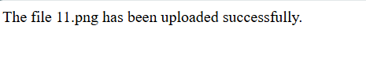



- Write a PHP script to create a session. Verify the persistence of the session throughout various
pages. Finally destroy the session.

Code:

<?php
// Start the session
session_start();

// Store data in session variables
$_SESSION["username"] = "Priyanshu_Shrestha";
$_SESSION["role"] = "student";

echo "Session started. Session variables are set.<br>";
echo '<a href="6_session_check.php">Go to next page</a>';
?>

Output:
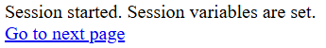

Code:

<?php
// Start the session
session_start();

// Check if session variables are set
if (isset($_SESSION["username"]) && isset($_SESSION["role"])) {
echo "Session is active.<br>";
echo "Username: " . $_SESSION["username"] . "<br>";
echo "Role: " . $_SESSION["role"] . "<br>";
} else {
echo "No session variables found.<br>";
}

echo '<a href="6_session_destroy.php">Destroy Session</a>';
?>
Output:

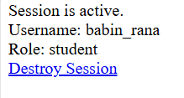

Code:

<?php
session_start();
session_unset();
session_destroy(); // Destroy the session

echo "Session has been destroyed.<br>";
echo 'Check session again</a>';
?>

Output:

